COVID ASSIGNMENT

What exactly I have done?

I have analysed COVID-19 pandemic data from January 2020 to august 2021 and given my inferences

Stakeholders/audience for the project:

Government of India, State Governments, Doctors, General public

Why this data was collected in first place?

This data was collected in first place to understand the effect of COVID-19 on different region/places of India, to analyse the infection rate in public, to help Stakeholders sort out strategy to contain the spread of the virus.

What questions I am trying to answer?

Following are some question which I am trying to answer in this file:

1.Top/bottom 10 states with highest number of Confirmed cases

2.Top/bottom 10 states with highest number of Cured cases

3.Top/bottom 10 states with highest of Death percentage

4.Top/bottom 10 states with highest number of Total Samples

5.Top/bottom 10 states with highest number of Negative cases

6.Top/bottom 10 states with highest number of Positive cases

7.Male and Female Vaccination

8.Covaxin and Covishield Vaccination

9.Doses administered vs People Vaccinated

**Q1.a. top 10 states with highest number of confirmed cases**

Q1.b. bottom 10 states with lowest number of cases

Q2.a. top 10 states with highest number of cured cases

Q2.b.bottom 10 states lowest cured cases

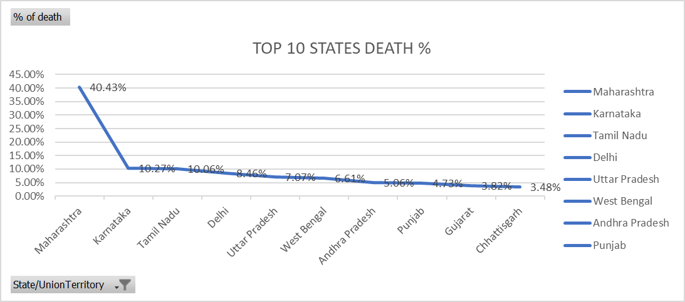Q3. Top/bottom 10 states with highest/lowest number of deaths %

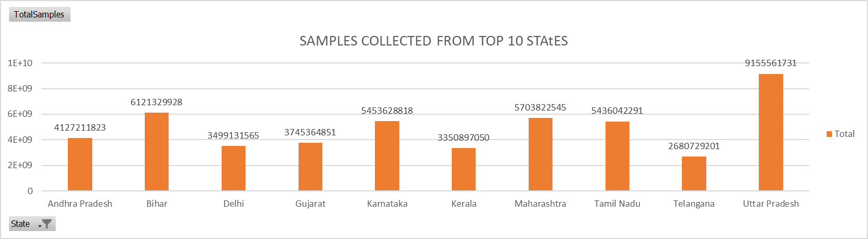Q4. Top/bottom ten states with highest/lowest number of total samples collected

Q5 top/bottom 10 states with highest positive cases

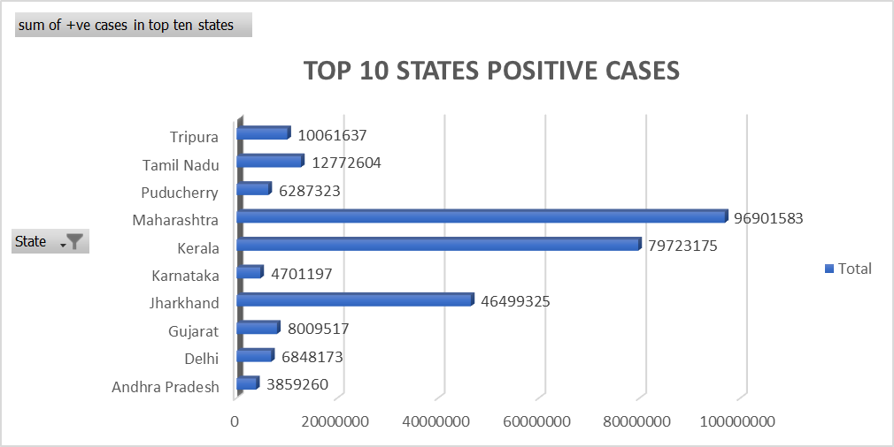

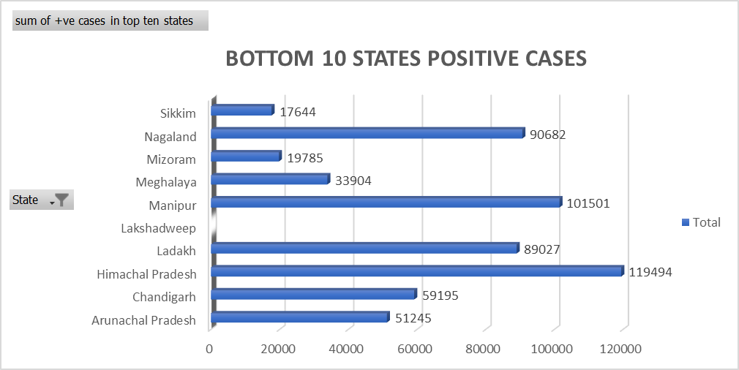

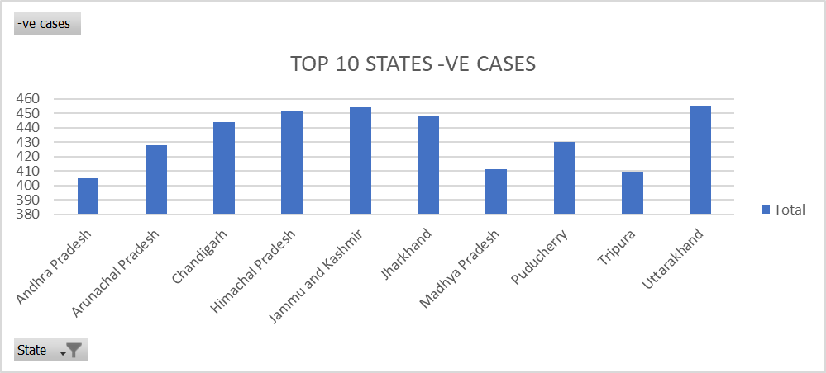Q6. Top/bottom states -ve cases

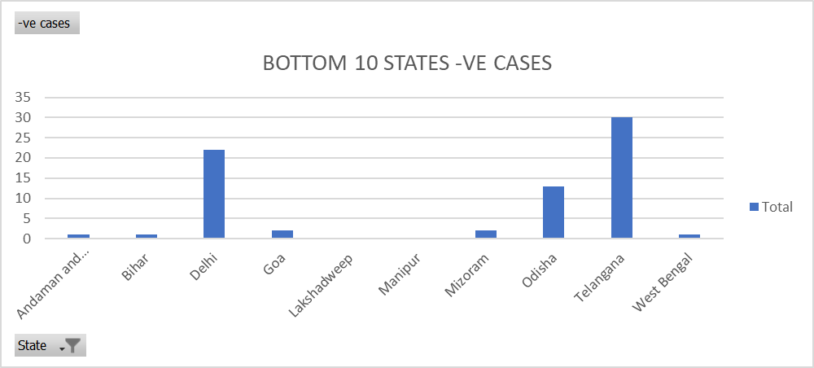

Q7. total number of covishield and covaxin adminstered till july2021

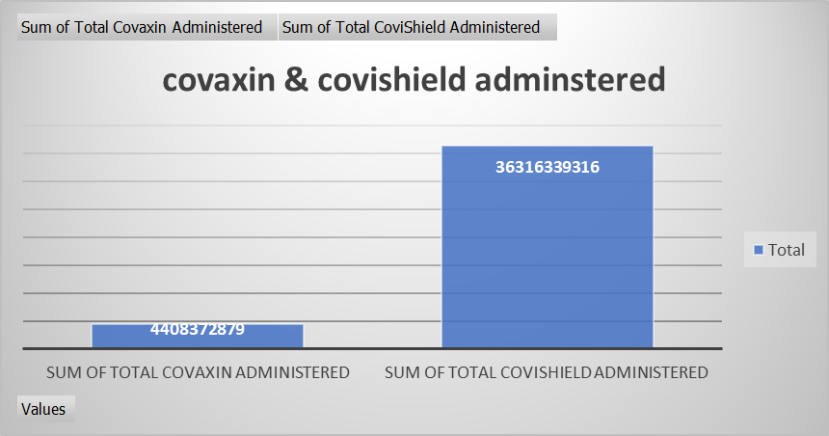

Q8. Total male and female vaccinated

